# **Week 1 - 2: Nash Equilibrium (Final)**

Normal-Form Games

* Matrix representation
* A set of players
* Each player has a set of possible actions
* An action profile: a vector 
  + basically any available combination of actions by players = 1 action profile
* Utility of player i from any action profile is value

Pure Nash Equilibrium

*Best Response:* Given everyone else’s actions, player chooses the best action that allows him/her to maximize his/her utility

Randomized Actions

* : probability distribution over player i’s actions
* Mixed strategy profile: 

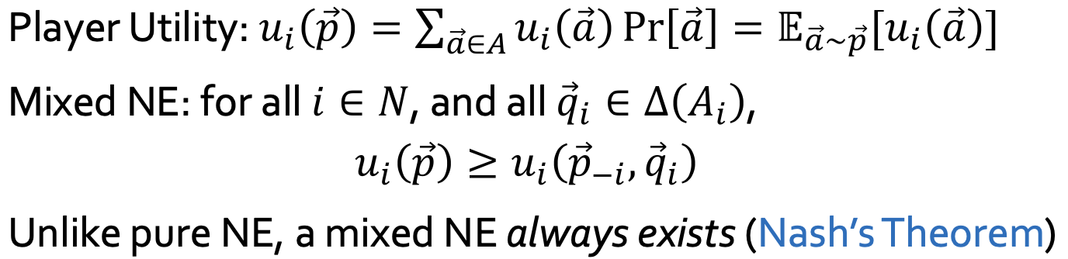

Computing NE in 2*2 game

|  | Chinese (q) | Indian (1 - q) |
| --- | --- | --- |
| Chinese (p) | 5, 4 | 1, 1 |
| Indian (1 - p) | 0, 0 | 4, 5 |

**Case 1: At least 1 player plays pure strategy**

* Row = Chinese → Col = Chinese → Row = Chinese → (Chinese, Chinese)
* Row = Indian → Col = Indian → Row = Indian → (Indian, Indian)
* Col = Chinese → Row = Chinese → Col = Chinese → (Chinese, Chinese)
* Col = Indian → Row = Indian → Col = Indian → (Indian, Indian)

**Case 2: Both players mix between strategies**

* Assume Row plays (Chinese, Indian) with probability (p, 1-p) and Col with probability (q, 1-q) where 0 < p, q < 1
* XXX player indifferent means that, regardless of the opponent’s strategy, for any action that XXX takes the payoff of XXX will be the same
* Row player indifferent:
  + payoff of playing Chinese = payoff of playing Indian
  + 5q + 1(1-q) = 0q + 4(1-q)
  + q = 3/8
* Col player indifferent:
  + 4p + 0(1-p) = 1p + 5(1-p)
  + p = 5/8
* NE = (5/8 Chinese + 3/8 Indian, 3/8 Chinese + 5/8 Indian)

**Dominant Strategies:**

if an action is strictly dominated by some strategy , then action is never played with any positive probability in any Nash equilibrium.

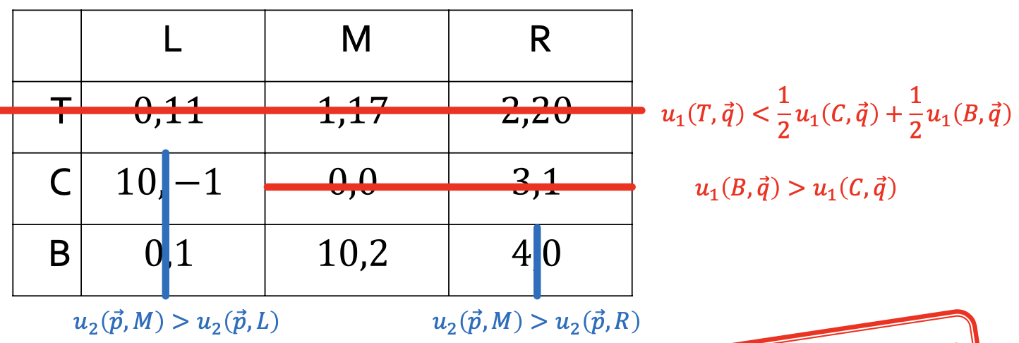

**Theorems/Facts:**

1. There can exist a game with no pure NE
2. Nash’s Theorem: Unlike pure NE, a mixed NE always exists (mixed NE here is a superset of pure NE)
3. Linearity of payoffs: If playing T yields payoff x to playing ⅓ L + ⅔ R and playing B also yields payoff x. By linearity of payoffs, playing any mixture of T and B also yields x.

**Assignment 1 Q2:**

|  | **L** (q) | **R** (1-q) |
| --- | --- | --- |
| **C** (p) | 2, 2 | 2, 2 |
| **B** (1-p) | 5, 5 | 2, 2 |

**Case 1: at least 1 player plays a pure strategy**

* Row = C → Col = anything→ row player choosing C is a best response to this only when Col chooses R → (C, R)
* Row = B → Col = L → Row = B → (B, L)
* Similar reasoning for Col

**Case 2: Both players mix between strategies**

* Assume Row plays (C, B) with probability (p, 1-p) and Col plays (L, R) with probability (q, 1-q) where 0 < p, q < 1
* Row player indifferent:
  + 2q + 2(1-q) = 5q + 2(1-q) ⇒ q = 0
  + Contradicts the assumption that 0 < q < 1

Assignment 2 Q2:

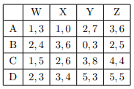

1. Which actions are being dominated in the **original game**?

D strictly dominates A and C.

⅓ Y + ⅔ Z strictly dominates W.

Although Z and X strictly dominate Y here, the above table is not the original game anymore.

|  | **X** | **Y** | **Z** |
| --- | --- | --- | --- |
| **B** | 3, 6 | 0, 3 | 2, 5 |
| **D** | 3, 4 | 5, 3 | 5, 5 |

|  | **X** (q) | **Z** (1-q) |
| --- | --- | --- |
| **B** (p) | 3, 6 | 2, 5 |
| **D** (1-p) | 3, 4 | 5, 5 |

**Case 1: At least 1 player plays a pure strategy**

Row = B → Col = X → Row = Anything → (B, X)

Row = D → Col = Z → Row = D → (D, Z)

Col = X → Row = indifferent

* Row = p*B + (1 - p)*D for any 0 <= p <= 1
* So, for X to be a best response, payoff of playing X must be greater than Z:
  + 6*p + 4*(1-p) >= 5*p + 5*(1-p)
  + For this inequality to be true, ½ <= p <= 1

Col = Z → Row = D → Col = Z → (D, Z)

**Case 2: Both players play between mixed strats**

Assume Row player plays (B,D) with a +ve probability of (p, 1-p) and Col player plays (X, Z) with a +ve probability of (q, 1-q).

Row player indifferent:

* 3q + 2*(1-q) = 3q + 5*(1-q) => q = 1
* q = 1 means col player plays X only. This contradicts the assumption that both players play positive probability on both actions.

(D,Z), (pB + (1 - p)D, X) for ½ <= p <= 1

# **Week 3: Auctions**

Single-Item Auction

* seller has 1 object for sale
* Each bidder values the item at

English Auction - Single Item:

* auctioneer sets a starting price
* bidders take turns raising their bids
* person who makes the last bid wins and pays his bids

**Example:**

v1 = 50, v2 = 30, v3 = 70, delta = 1

* Auction starts at p = 0;
* while p < 30, all bidders are submitting bids
* At p = 30, player 2 stops bidding
* At p = 50, player 1 stops bidding
* if player 3 was the one to bid 50, she wins and pays 50
  + p1 payoff = p2 payoff = 0
  + p3 payoff = 70 - 50 =2 0
* if player 1 was the one to bid 50, player 3 bids 51 and wins
* winning bid = highest value or highest value + delta

Japanese Auction - Single item

* auctioneer sets a starting price then starts raising it
* a bidder can dropout, and cannot return
* last bidder gets the object and pays the current price (2nd price auction)

**Example:**

v1 = 50, v2 = 30, v3 = 70, delta = 1

* auction starts at p = 0
* At p = 30, player 2 drops out
* At p = 50 player 1 drops out
* Player 3 wins and pays 50
* Less submission of bids than English auction
  + 2 vs 50 messages

Vickrey (2nd price) Auction

* All bidders submit bids simultaneously in sealed envelopes
* highest bidder wins and pays the 2nd highest price
* As a game:
  + n players (bidders)
  + actions: bids (continuous space action)
  + payoff: if a player values the object at v and the 2nd highest bid is p
    - payoff = v - p, if she gets the object
    - payoff = 0

**Truthful bidding is a dominant strategy**

Proof: Suppose you value the item at v, and other players’ bids are b1 <= … <= bn

Case 1: v >= bn-1

* If bid b >= bn-1, win and pay bn-1
* Payoff = v - bn-1 = payoff from truthful reporting v
* If bid b < bn-1, lose → payoff = 0

Case 2: v < bn-1

* If bid b >= bn-1, win and pay bn-1
* Payoff = v - bn-1 < 0
* If bid b < bn-1, lose → payoff = 0 = payoff from truthful reporting v

Vickrey Clarke Groves (VCG) Mechanism

* **Truthful reporting is a dominant strategy**
* Selects soically optimal outcome

1. Choose some outcome o* that maximises the sum of the utility (v-payment) of all players
2. Payment that agent j must take = 2nd price

= externality that j imposes on other agents

= (max total welfare of others if j were absent) - (max total welfare of others when j is present)

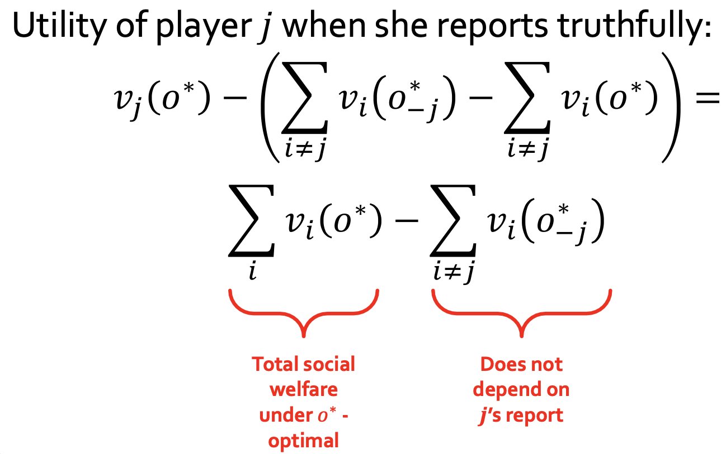

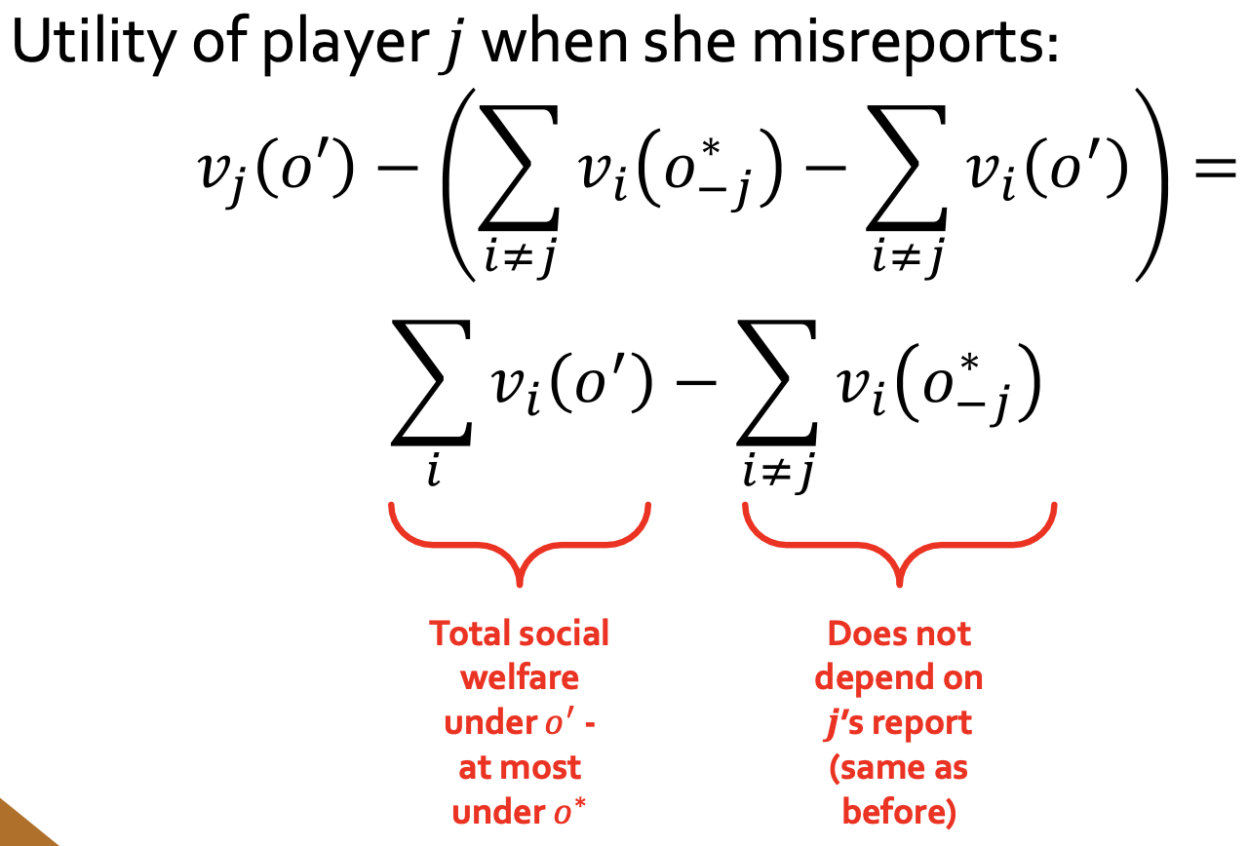

Combinatorial Auctions

* m (possible distinct) items for sale
* (n + 1)m possible allocations/outcomes
* Bidders have diff valuation for diff subset (need for preference elicitation)
* VCG is truthful, but some challenges
  + Due to preference elicitation, finding the optimal outcome may be NP-hard
  + Revenue non-monotonicity

Revenue Non-monotonicity

* Bidders: p1, p2
* Items: A, B
* P1: only wants both items together
  + v1(A, B) = 1
  + v1(A) = v1(B) = 0
* P2: only wants A
  + v2(A, B) = v2(A) = 1
  + v2(B) = 0
* Revenue of VCG (auctioneer) = 1, either
  + AB to v1 → v1 pays 1, or
  + A to v2 → v2 pays 1
* P3 added: wants only B
  + v3(A, B) = v3(B) = 1
  + v3(A) = 0
* Revenue of VCG drops to 0
  + VCG maximise total social welfare, so allocate A to p2 and B to p3
  + P2’s payment (A) = 0
    - both p1 and p3’s valuation is 0 for A
    - Max utility of others when P2 is absent = 1 (prev case)
    - Max utility of others when P2 is present = 1
  + P3’s payment (B) = 0

Assignment 3 Q2

If two bidders in a single-item auction cooperate, i.e., they both submit bids to the mechanism, but they want to maximize their joint utility. Can VCG still extract truthful valuations from the bidders?

* No.
* If there are only two bidders and both bidders say that they value the item at 0, then the bidders obtain a higher joint utility than if they were to bid truthfully.
* If there are more than two bidders, a similar situation occurs when all but two bidders have value 0—the two colluding bidders can bid some small ε each.
* Collusion can be highly beneficial in VCG

# **Week 4.1: Facility Location**

Model

* Players: N = {1,...,n}
* Each with a location xi
* Mechanism f: ℝn → ℝ
* Assume x1 <= x2 <= … <= xn

Social Cost

* Cost of player i =
* Total cost:
* Max cost of player i =

**Mechanisms**

Minimise the max cost → midpoint

* Not truthful: incentive to misreport for the facility to locate nearer to reduce cost

Median mechanism

* Choose median player’s location (rounded down if there are two median players)
* Strategyproof = truthful
* Socially optimal for the total cost objective

Leftmost mechanism

* Strategyproof
* If player = leftmost, no incentive to misreport (truthful report → cost = 0)
* Else, the only way the player can change the outcome is to report a location further to the left than the leftmost location. But then the player’s cost would increase rather than decrease.

**Theorem**

* Any deterministic truthful mechanism has a worst-case approximation ratio of at least 2 to the maximum cost
  + Leftmost mechanism is the worst-case approximation ratio
  + Median mechanism but ½ n of players are on the same leftmost location

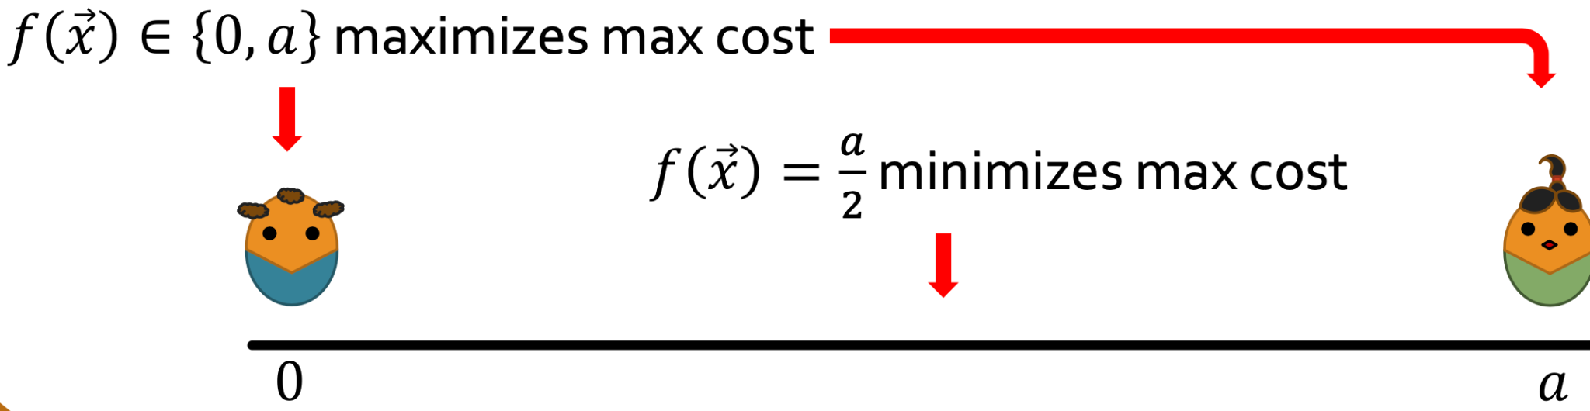

* any randomized strategyproof mechanism has a max-cost approximation ratio of at least 3/2

Assignment 4 Q2

There are two players on an infinite street, and one facility to be located. The cost of an agent is his/her distance to the facility. Let f be a randomized mechanism that, upon receiving the players’ reports {x,y} with x ≤ y, returns x with probability 1/6, y with probability 1/6, and (x+y)/2 with probability 2/3.

* Approximation ratio of f wrt total cost:
  + d = y - x
  + Total cost = ⅙ (0 + d) + ⅙ (d + 0) + ⅔ (d)
  + approximation ratio = 1
* approximation ratio of f wrt max cost
  + Max cost = ⅙ (d) + ⅙ (d) + ⅔ (d/2) = 2d/3
  + Approximation ratio = (2d/3) / d/2 = 4/3
* If f truthful
  + No
  + Suppose the locations of the two players are 0 and 1. If both players report truthfully, p2’s expected cost is ⅙ (1) + ⅙ (0) + ⅔ (½ ) = ½
  + If p2 reports 2, f places the facility at
    - point 0 with probability 1/6,
    - point 2 with probability 1/6,
    - point 1 with probability 2/3.
  + P2’s expected cost = ⅙ (1) + ⅙ (1) + ⅔ (0) = ⅓ < ½

# **Week 4.2: Routing Games**

Price of Anarchy (PoA)

* ratio of the social cost under the worst Nash Equilibrium and the socially optimal solution
* PoA(G) = WorstNash(G) / OPT(G)
* In non-atomic routing games, all equilibrium flows have the same cost → can take any eqm as the numerator
* Cost here is always per unit

Non-Atomic Routing Game

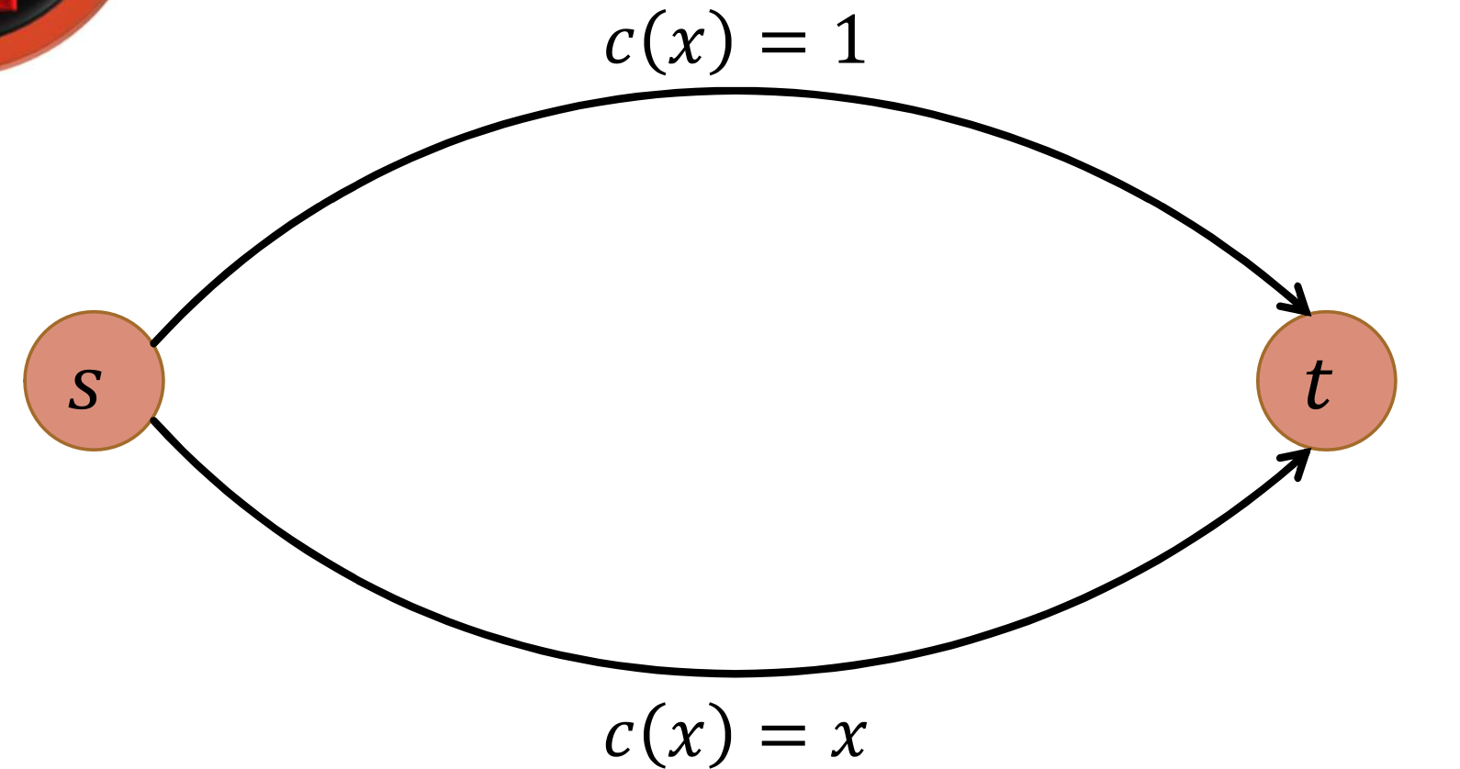

* c(x) = x <= 1
* Suppose there is 1 unit of traffic
* x units to bottom, (1-x) units to top
* Cost, C = x(x) + (1-x)(1) = x2 - x + 1
* dC/dx = 2x - 1
* Lowest cost ⇒ dC/dx = 0 ⇒ x = 1/2
* PoA = 2/(1 + 1/2) = 4/3

Atomic Routing Game

* k units of traffic, where k is a +v int
* Each unit must be routed as a whole (atomic)
* Each edge has a cost function

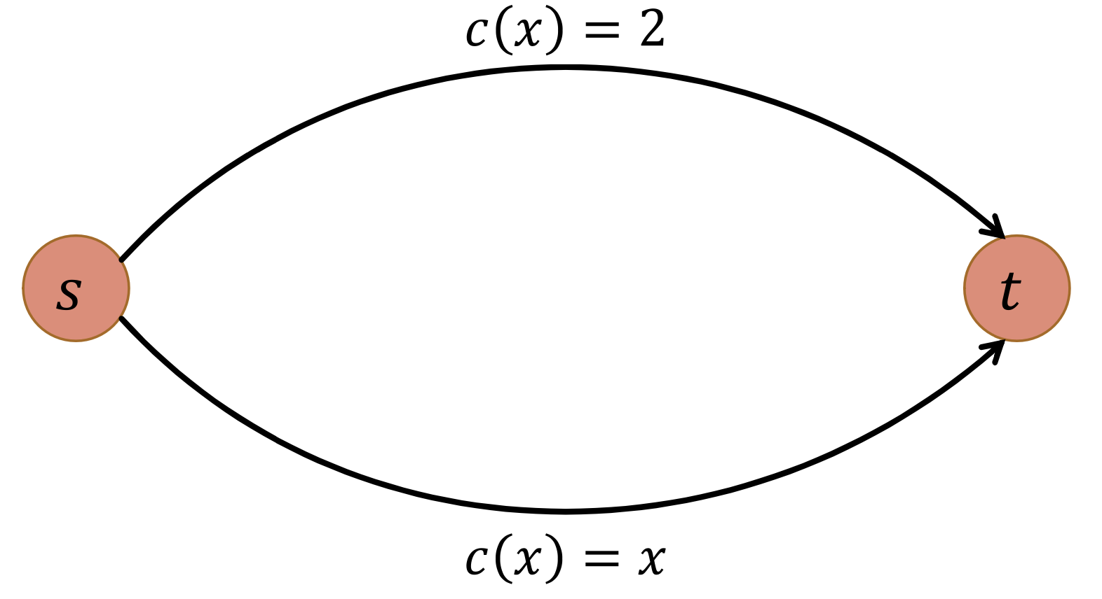

* c(x) = x <= 2
* 2 units of traffic:
  + OPT: 1 top 1 bottom → 3
  + WorstNash: both top/bottom → 4
  + PoA = 4/3

**Theorem:**

* In an atomic (and non-atomic) routing game, a pure NE flow always exists

Assignment 4 Q3 (Non-atomic routing)

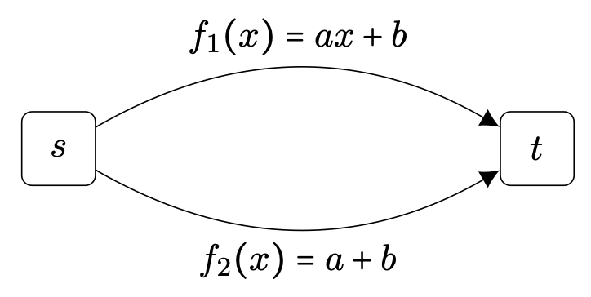

Total cost in the equilibrium flow

* All goes to top ⇒ a + b

Total cost in the optimal flow

* If x units of the traffic goes through the top edge and 1 − x through the bottom edge,
* the cost is
* c(x)=x(ax+b)+(1−x)(a+b)=ax2 −ax+a+b
* dc/dx = 2ax - a = 0 ⇒ x = ½
* c(½) = ¾ a + b

Price of anarchy

* PoA = (a + b) / (¾ a + b)
* Highest PoA when a >= 0 and b = 0: ¾

Assignment 4 Q3 (Atomic routing)

Route 3 units of traffic from s to t. There are 2 edges, the top edge with cost function g1(x) = x2 and the bottom edge with cost function g2(x) = x + 2.

Determine all pure NE

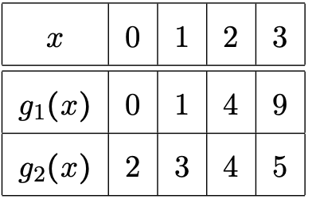

* all 3 units top,
  + g1(3) = 9 > g2(1) = 3
  + each unit has an incentive to switch to the bottom edge → reduce the cost from 9 to 3.
* all 3 units bottom,
  + g2(3) = 5 > g1(1) = 1
  + each unit has an incentive to switch to the top edge → reduce the cost from 5 to 1.
* 2 units top and 1 unit bottom.
  + g1(2) = 4 = g2(2)
  + 1 unit switching from the top edge to the bottom edge would not change its cost of 4,
  + g2(1) = 3 < g2(3) = 9
  + a unit switching from the bottom edge to the top edge would increase its cost from 3 to 9.
  + No incentive to switch → NE
* 1 unit top and 2 units bottom.
  + g1(1) = 1 < g2(3) = 5
  + 1 unit switching from the top edge to the bottom will increase its cost from 1 to 5
  + g2(2) = 4 = g1(2)
  + 1 unit switching from the bottom edge to the top edge would not change its cost of 4.
  + No incentive to switch → NE
* NE = {(2 top, 1 bottom), (1 top, 2 bottom)}

# **Week 5 - 6: Cooperative Games (Final)**

Induced Subgraph Games

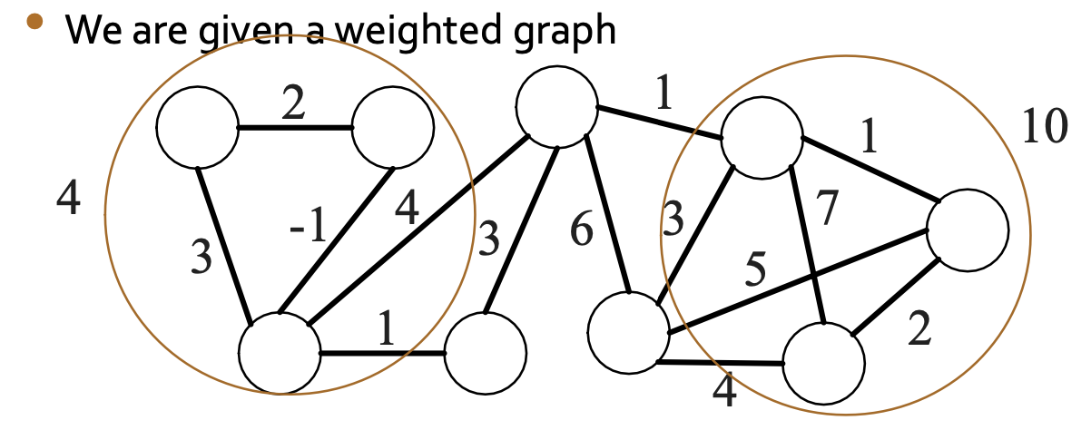

* **Players are nodes**
* Value of a coalition is the value of the total edge weights in the subgraph

Network Flow Games

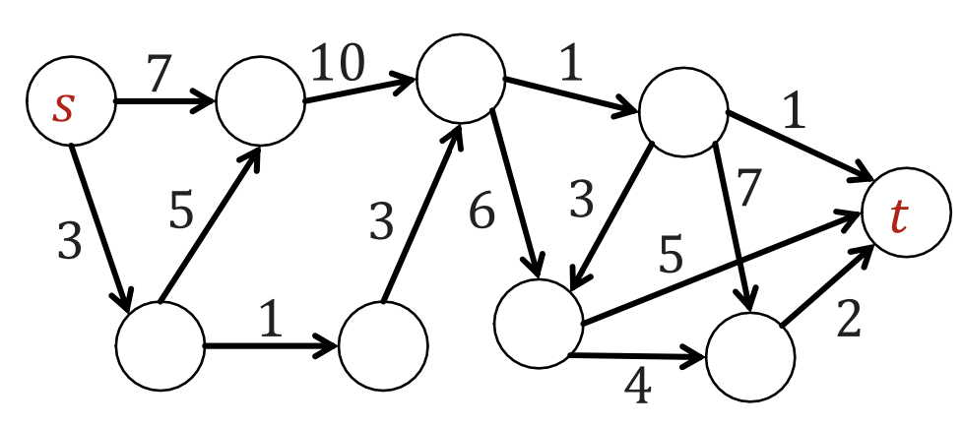

* **Players are edges**
* Value of a coalition is the value of the max flow it can pass from s to t

Weighted Voting Games <w1, …, wn; q>

* Each player i has a weight wi
* Value of a coalition is 1 if total weight >= q (win)
* 0 otherwise (lose)

Efficiency → All elements in the vector x must sum up to the v(N) i.e. value if the coalition is the entire group

Individual rationality → in a payoff vector x, each element i must have payoff greater than if the coalition was i alone

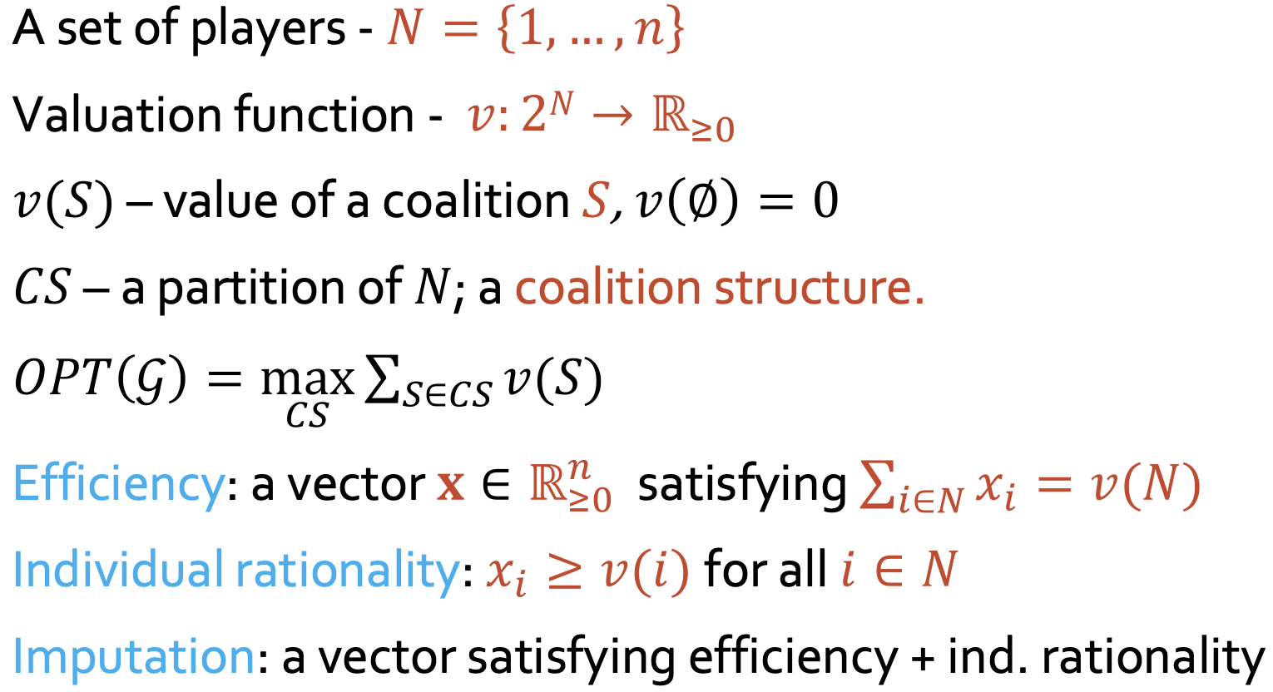

* xi  is the payoff for player i in the vector that belong to the core

| Monotone | For any S ⊆ T ⊆ N, v(S) ≤ v(T)  Value does not decrease as group size increases |
| --- | --- |
| Simple | Monotone and v(S) ∈ {0, 1} for all S |
| Superadditive | For disjoint S, T ⊆ N,  v(S) + v(T) ≤ v(S∪T) |
| Convex | For S ⊆ T ⊆ N and i ∈ N \ T,  v(S ∪ {i}) - v(S) ≤ v(T ∪ {i}) - v(T)  Joining a larger group yields more marginal benefits |

e.g. v({1}) = v({2}) = 0

v({3}) = v({1, 2}) = v({1, 3}) = v({2, 3}) = v({1, 2, 3}) = 1

* Monotone: Consider any S ⊆ T ⊆ N. If S = T, clearly v(S) = v(T). Otherwise, ∣S∣ < ∣T∣, and one can observe that v(S) ≤ v(T ) always holds.
* Simple: monotone and all payoffs are either 0 or 1
* Not Superadditive:

v({3}) + v({1,2}) = 1 + 1 > 1 = v({1,2,3})

* Not convex: v({3})−v(∅)=1−0>1−1=v({1,2,3})−v({1,2})

Core

* An imputation is in the core if
* Each subset of players is getting at least what it can make on its own
* Stable: no subset can deviate
* The core is a set of vectors in that satisfy linear constraints
* For 3 players:

E.g.

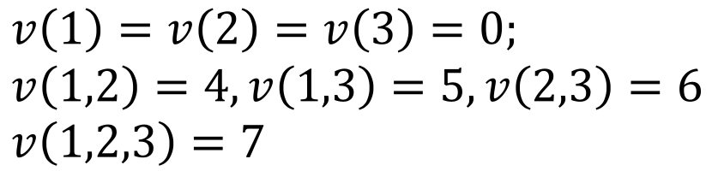

Adding up the last 3:

* Hence, the core is empty.
* v({1, 2, 3}) needs to be at least 0.5 higher for the core to be non-empty

Veto players

* A member of every winning coalition (cannot win without this member)
* Converse is not true, if a veto player is in the coalition, it does not mean the coalition will win

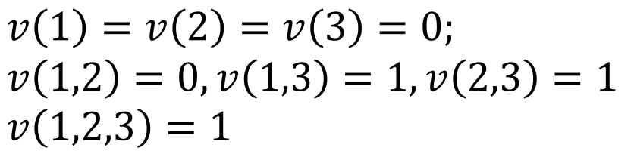

* Veto player = 3
* Core = (0, 0, 1)
* This example also shows payoff vector != Shapley value (⅙, ⅙, ⅔) → fairness != stable

**Theorem:**

* let G = <N, v> be a simple game; then Core(G) not empty iff has veto players.
  + The core has precisely the vectors that distribute the payoff only among veto players.
  + i.e. empty core iff no veto player
* The core of an induced subgraph game is not empty iff the graph has no negative cut.
  + i.e. empty core iff theres negative cut

**Fairness**

| Efficiency |  |
| --- | --- |
| Symmetry | Symmetric players are paid equally |
| Dummy | Dummy players are not paid → player that does not contribute to the payoff |
| Linearity | * Useful property that allows decomposition of complex games into simpler components |

**Shapley Value**

* Sum of marginal contribution of player i to the value of coalition
* Pivotal player: inclusion or exclusion of this player causes the value of the coalition to change
* E.g. weighted voting game <1,1,3,4;5>
  + Player 1 can only be additive when he is preceded by players whose combined weight is exactly 4
  + Either preceded by {2, 3} or {4}
  + 2, 3, 1, 4
  + 3, 2, 1, 4
  + 4, 1, 2, 3
  + 4, 1, 3, 2
  + 4 permutations out of 4! ⇒ 4/24 = ⅙
  + By symmetry, Sh1 = Sh2 = ⅙
  + Player 4 is always pivotal, unless he is the last or first ⇒ Sh4 = ½
  + By efficiency, Sh3 = 1 - ⅙ - ⅙ - ½ = ⅙

**Theorem**

* In an induced subgraph grame,
  + i.e. Shi = ½ sum of weights of all edges linked to nodei
* Shapley value is the only value satisfying efficiency, linearity, dummy, and symmetry.
* Ass6: If the payoff vectors x and y belong to the core of a game G, then for every α ∈ [0,1], the payoff vector αx + (1 − α)y belongs to the core of G as well.

# **Week 7: Stable Matching**

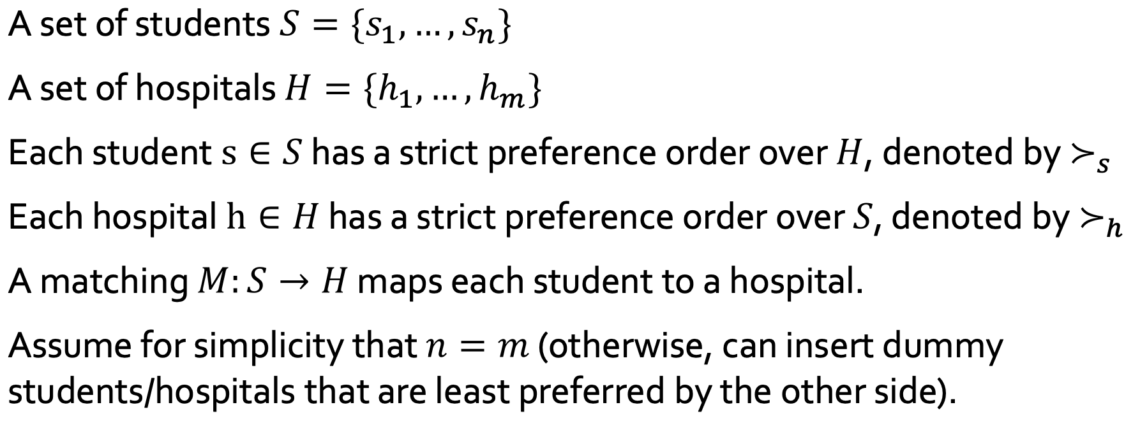

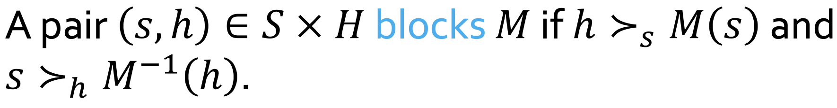

* A matching M is stable if theres no blocking pairs
* A stable matching always exists and can be found in polynomial time
* Can get two different matchings for student proposing and hospital proposing

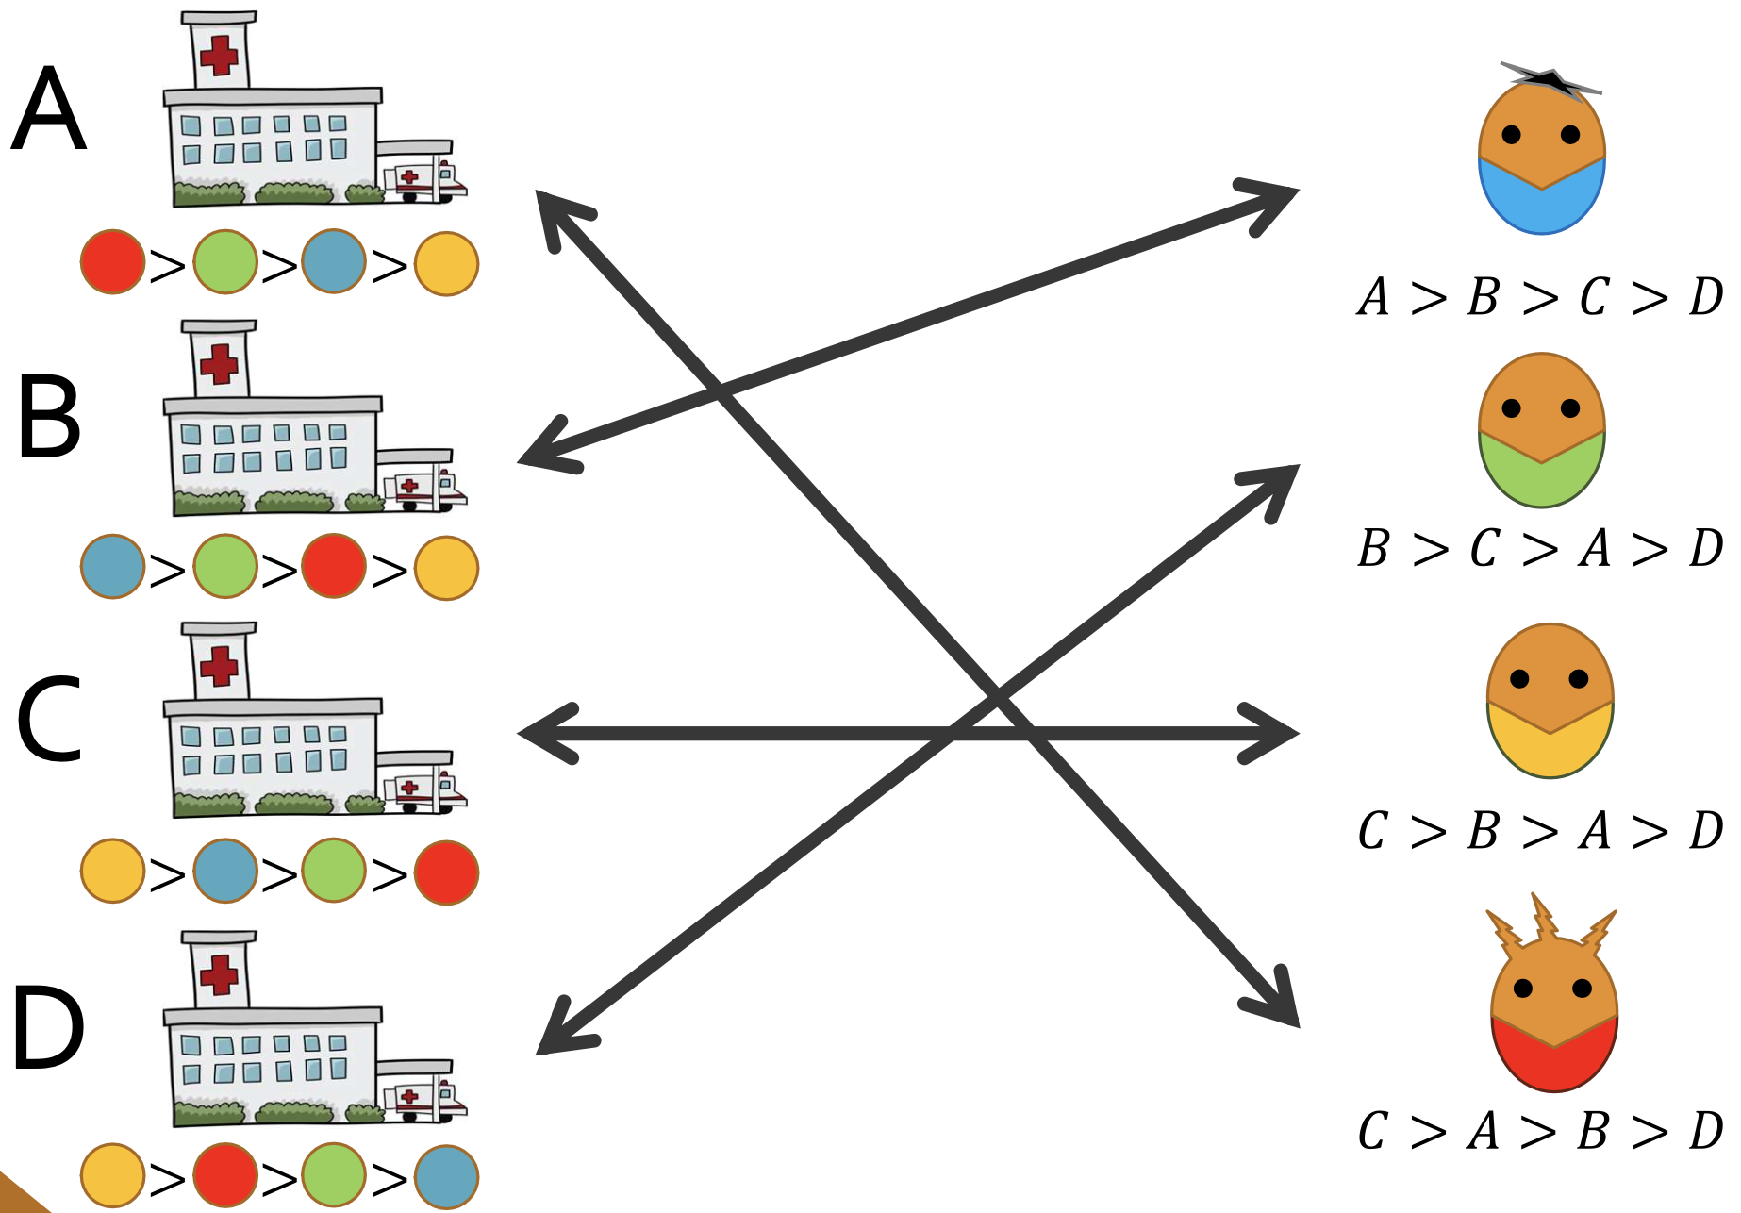

**Theorem**

* The G-S algorithm terminates in at most n2 iterations with a stable matching.
* Given a student , a hospital is called valid if there exists some stable matching such that M(s) = h
  + Let best(s) be the most highly-ranked valid hospital for s
  + Let worst(h) be the least highly-ranked valid student for h
* G-S assigns each student to the hospital best(s)
* G-S assigns each hospital to the student worst(h)

**Pareto Optimality - Can be satisfied by Efficiency**

* An outcome (x1, y1) Pareto dominates another outcome (x2, y2) if x1 >= x2 and y1 >= y2 and at least one of these two inequalities is strict
  + i.e. no player is worse off and at least 1 player is better off
* (x1, y1) is said to be a Pareto improvement of (x2, y2)
* An outcome (x, y) is Pareto optimal if it is not Pareto dominated by any other outcome

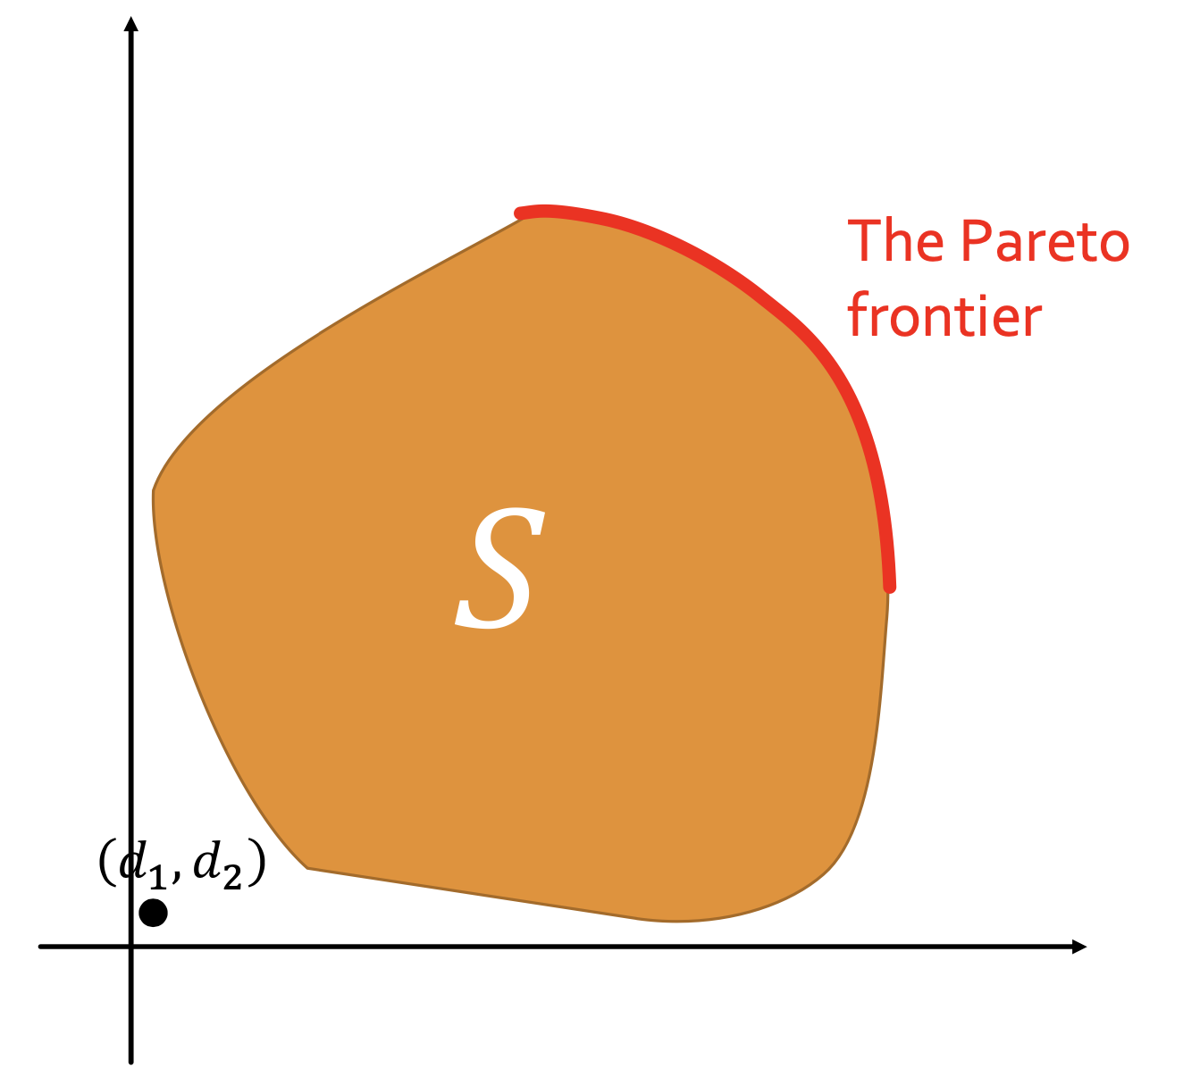

Pareto-frontier is a set of Pareto-optimal solutions

* Satisfies the efficiency property
* Might not satisfy other properties

Efficiency

No outcome (v1, v2) Pareto dominates (f1(S, d), f2(S, d))

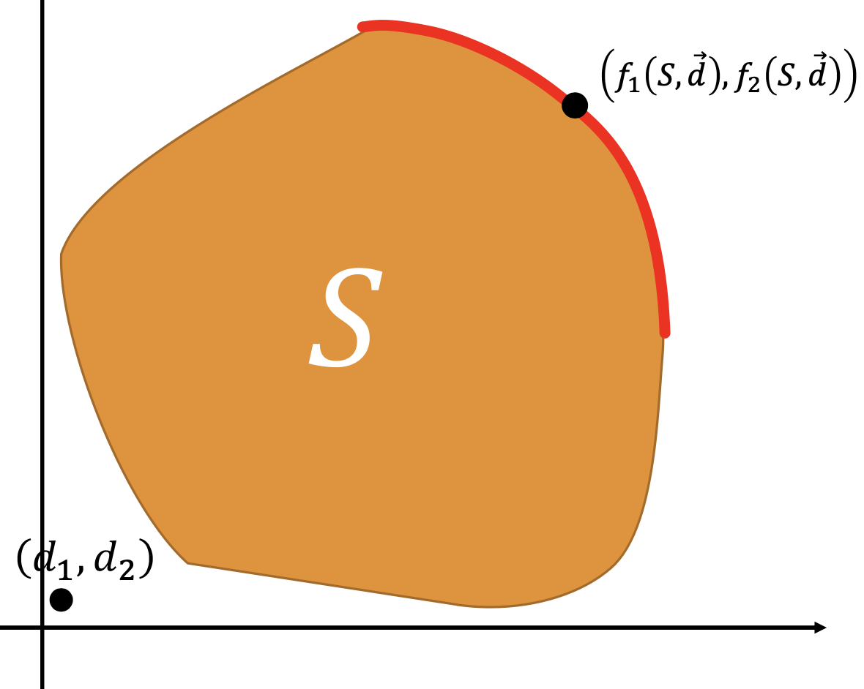

Symmetry

If you switch the roles of the elements in S and d (i.e., if you permute or transpose the elements), the outcome from the functions f1 and f2 should also switch in a similar manner. This ensures that the function treats all players or elements symmetrically.

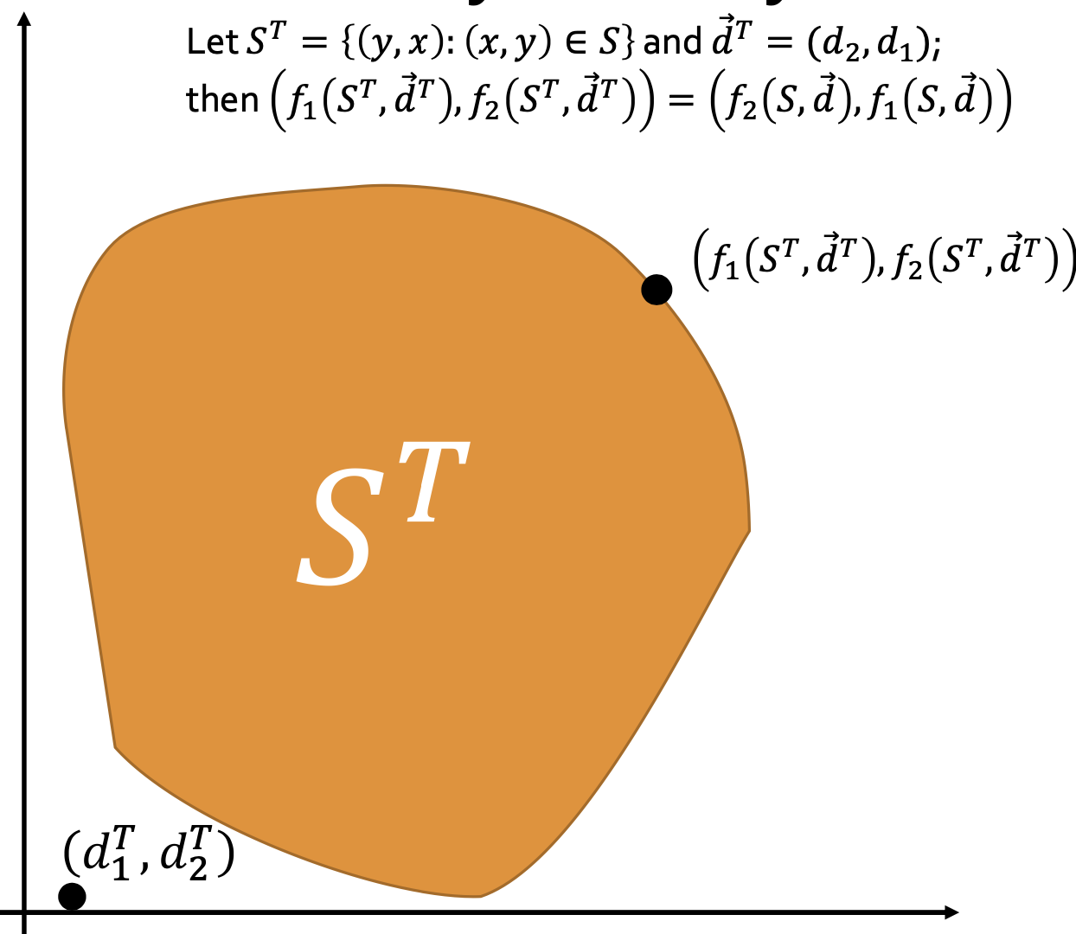

Independence of Irrelevant Alternative (IIA)

* Suppose our choice is d ∈ S’ and S’ ⊆ S, restricting our choices from S to S’ should not affect our final choice
* i.e. the selection of an outcome shouldn't be influenced by the presence or absence of alternatives that weren't chosen.

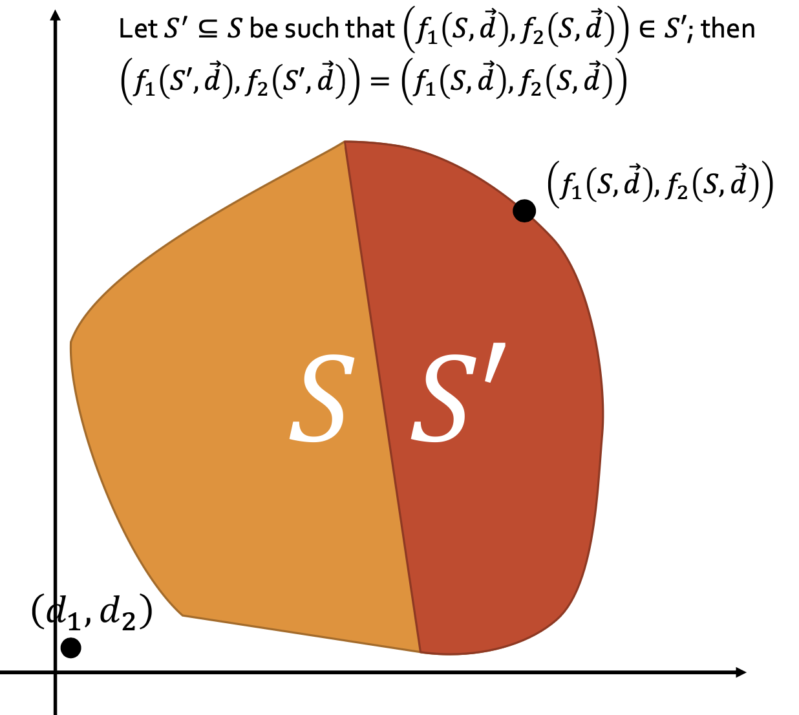

Invariance under Equivalent Representations (IER)

* For any scalars α1 and α2 from the real numbers, and β from R^2, the value of the function for scaled and translated utilities should be the scaled and translated value of the function for the original utilities.
* It ensures that the function is consistent even if the utilities of players are represented in different ways (e.g., using different scales or units), provided they convey the same relative preferences.

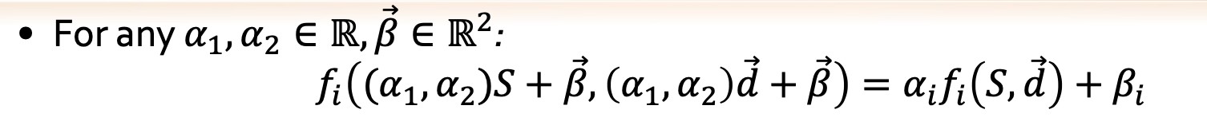

**Nash Bargaining Solution**

* Aims to maximize the product of the player’s utilities above their disagreement points, d
* If 2 players are in symmetric positions, (i.e. same utilities and the same disagreement points), the Nash Bargaining solution will allocate same utility to both players
* Capture a fair compromise between players by maximizing mutual benefits

| Utilitarian | Max sum of all utilities → increase total happiness   * Efficiency * IIA * Symmetry * IER |
| --- | --- |
| Nash bargaining | Max product of all utilities   * only solution that satisfies efficiency, symmetry, IIA and IER. |
| Egalitarian | Maximin of utilities → for fairness maximization   * (v1 - d1) = (v2 - d2) * Efficiency * Symmetry * IER * IIA |

* All solutions fulfil efficiency, hence all have pareto optimal

Lagrange:

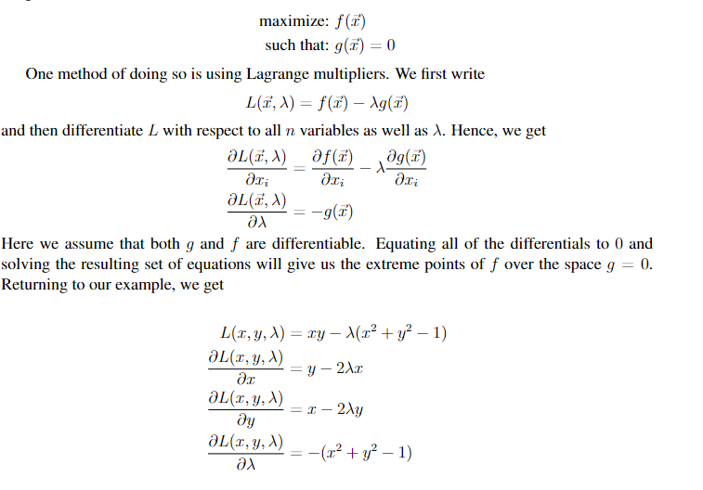

f(x) is the solution; g(x) is the given relationship between x and y.

Note:

* Always check the range when computing max points
  + E.g.
  + : x = 0 ⇒ neither min nor max
  + In fact, max occurs at x = 1 (min at x = -1)
* if all hospitals have the same preference list over students, then there exists a unique stable matching.

Assignment 7

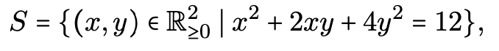

Nash Bargaining solution

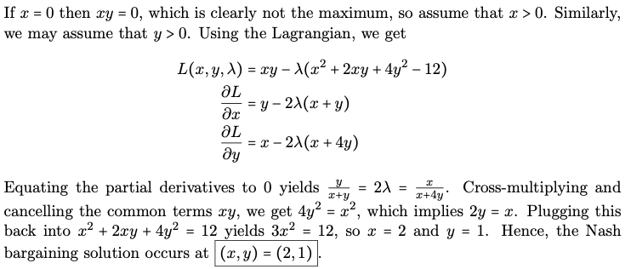

Utilitarian solution

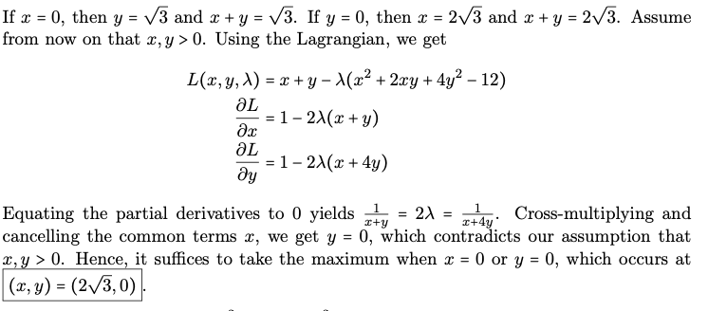

Egalitarian solution

* Increase in x → decrease in y
* Maximin occurs when x = y
* 7x2 = 12, i.e., x = √(12/7) = 2√(3/7) = y

# **Week 8: Fair Allocation of Indivisible Goods**

* Players N = {1, 2, ...,n}
* Indivisible goods G = {g1, g2, . . . , gm}
* Player i has value vi(g) for good g.
* Unless noted otherwise, assume that valuations are additive/monotone:
  + vi(G′) = Σg∈G′ vi(g) for all G′ ⊆ G
* Ease of elicitation (each agent has m values instead of 2m)
* Does not allow for complements/substitutes
* An allocation is a partition of the goods, A = (A1, A2, . . . , An), where bundle Ai is allocated to player i.

**Fairnesss Criteria:**

1. Proportionality: for all i in N
   * Player’s valuation for their assigned bundle is at least 1/n of their valuation of the set of goods
2. Envy-freeness:
   * Both notion are equivalent for n = 2
   * For n >= 3, envy-freeness is the stronger notion

Envy-freeness up to one good (EF1)

* Player i may envy player j, but the envy can be eliminated by removing a good from j’s bundle (pairwise).
* Formally, for any i, j ∈ N, if Aj ̸= ∅, then there exists g ∈ Aj such that vi(Ai) ≥ vi(Aj \{g}).
* Max utilitarian welfare ⇏ EF1
* Max Nash welfare ⇒ EF1

Round-Robin Algorithm

* Each player take turns to choose their fav good
* Satisfies EF1
  + If i is ahead of j in the round-robin ordering, then in every “round”, i does not envy j.
  + If i is behind j in the ordering, we consider the first round to start with i’s first pick. Then i does not envy j up to j’s first good.
* Satisfies s-EF1
  + An allocation A = (A1, . . . , An) is said to be strong EF1 (s-EF1) if for every player j with Aj ≠ ∅, there exists a good gj ∈ Aj such that for all i ∈ N ∖ {j}, it holds that vi(Ai) ≥ vi(Aj ∖ {gj}).
  + i.e. all other players only envy one good from each player
  + if i is ahead of j in the round-robin ordering, then i does not envy j
  + if i is behind j, then i’s envy towards j can be eliminated by removing the first good that j picks. Hence, for each j ∈ N, if Aj is nonempty, we can choose gj to be the first good that j picks.
* May not satisfy EFX

Envy-Cycle Elimination Algorithm (not deterministic)

1. Allocate 1 good at a time (arbitrary order)
2. Maintain an envy graph with
   * player as nodes, and
   * a directed edge i → j if i envies j wrt the current (partial) allocation
3. At each step, the next good is allocated to a player with no incoming edge
   * Any cycle that arises is eliminated by giving j’s bundle to i for any edge i → j in the cycle, i.e. rotate the bundle

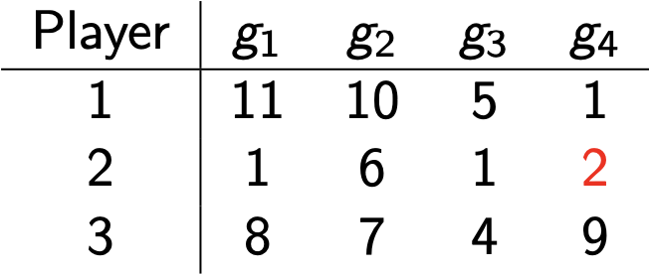

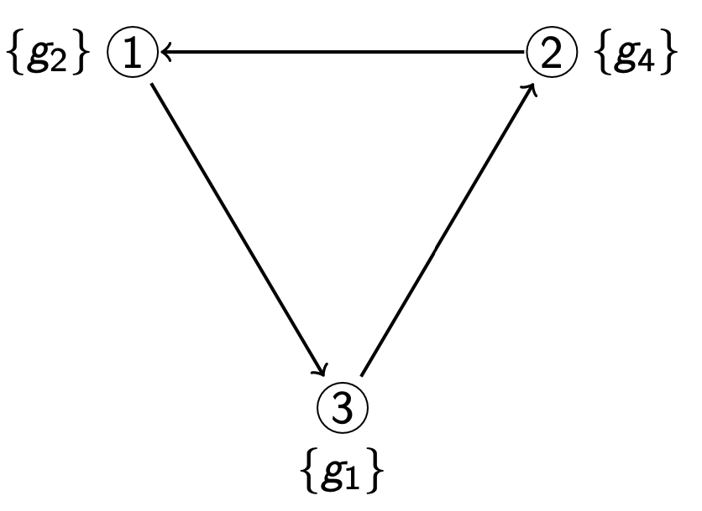

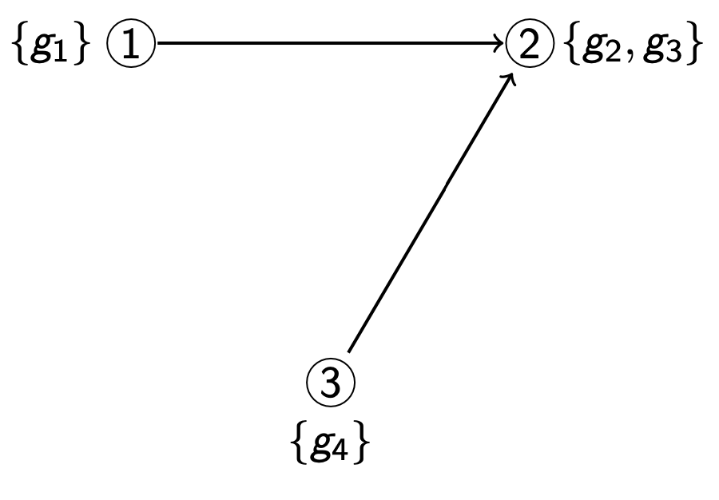

**Claims**

1. At each step, the procedure of eliminating cycles must end
   1. Each time we eliminate a cycle, the utilitarian welfare increases (#envy edges decreases)
2. When the procedure of eliminating cycle ends, there is an unenvied player (i.e. a source in the envy graph)
   1. Only 1 edge needs to be broken
3. At each step, the partial allocation is EF1
   1. Whenever theres a cycle, the cycle will be broken before allocating the next one
   2. The good is allocated to an unenvied player, so any envy towards that player is at most one (newly allocated good)
4. May not satisfy EFX

**Maximum Nash Welfare**

* Nash welfare of an allocation is the product of all players’ utilities
* An allocation that maximizes Nash Welfare, called Maximum Nash Welfare (MNW) allocation is EF1.
* If a player’s utility = 0, exclude from MNW
* Proof:
  + Suppose player i envies player j even after removing any good from j’s bundle
  + Consider a good g in j’s bundle that max the ratio vj(g)/vi(g), moving g to i’s bundle increases the Nash welfare
* Nash welfare allocation is always Pareto-optimal

EFX

* Remove any g from j then i no longer envy j
* For any i, j ∈ N and any g ∈ Aj, we have vi (Ai) ≥ vi(Aj \ {g})
* Envy-free ⇒ EFX ⇒ EF1
* May not satisfy EFX

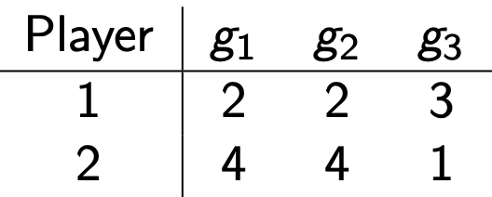

* The allocation with A1 = {g1} and A2 = {g2, g3} is EF1 but not EFX.
  + Remove g2 → v1(A2) = 3 > 2 = v1(A1)
* The allocation with A1 = {g3} and A2 = {g1, g2} is EF1 and EFX.

Claims

* EFX always exists when n = 2 or 3
* EFX not guaranteed when n >= 4

Maximin Share (MMS)

* Relaxation of proportionality
* Player divides the goods into n bundles to max the value of the min-value bundle

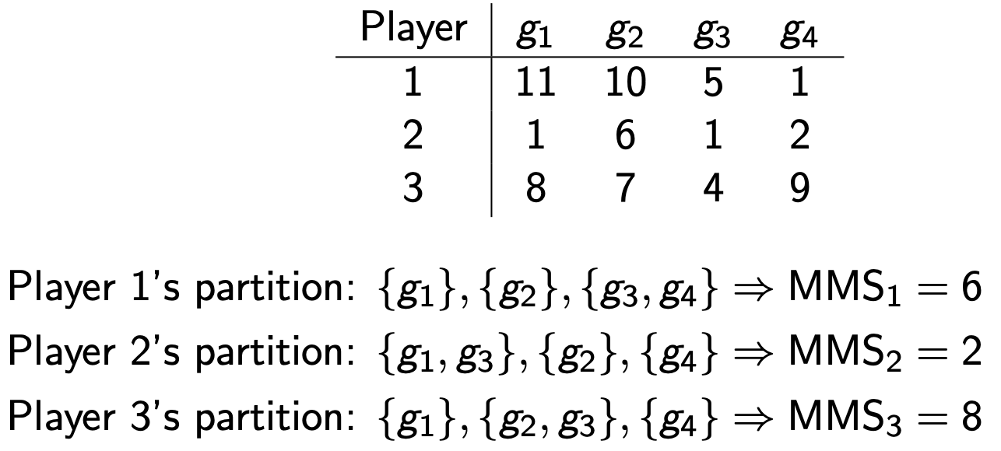

* An allocation that gives every player at least his MMS always exists when there are 2 players, but not when there are >= 3 players
* For any number of players, we can always give every player at least ¾ of his MMS

Query complexity

* Especially relevant when valuations are not additive
* The envy-cycle elimination algorithm can be implemented using O(nm) queries, even with monotonic valuations.
  + It suffices to query the value of each agent for the n bundles in each partial allocation in order to construct the envy graph.
  + Since there are m partial allocations, the number of queries is O(nm).
* For 2 agents with monotonic valuations, O(log m) queries suffice
* Any deterministic EF1 algorithm needs Ω(log m) queries.
  + Holds even for identical additive valuations where each player has value 1 for two goods and 0 for the rest.
  + In any EF1 allocation, the two valuable goods must be separated

Miscellaneous examples

Computing Pure NE:

|  | Stay Quiet | Confess |
| --- | --- | --- |
| Stay Quiet | -1, -1 | -3, 0 |
| Confess | 0, -3 | -2, -2 |

Row = SQ → Col = Confess → Row = Confess

Row = Confess → Col = Confess → Row = Confess → (Confess, Confess)

Col = Confess → Row = Confess → Col = Confess → (Confess, Confess)

Col = SQ → Row = Confess → Col = Confess